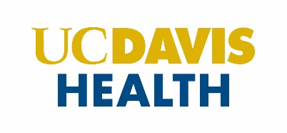

Faculty Development

FACTS ROI Grant Submission Cohort

I nominate ___________________________________ for the FACTS RO1 Grant Submission Program.

Please speak to this faculty member’s potential and readiness as a researcher and grant applicant.

If selected, I commit that this faculty member will be provided with a minimum of five (5) hours per week of protected time to participate in the program.

Signature Date

Print Name

Title

Please upload this completed document with your application.

Nomination and Statement of Commitment 2021-2022