Professional Practice Gap Analysis Tool for Planning Continuing Professional Development
A gap analysis is a valuable tool during the beginning of an educational plan to take you from “I think I know what the problem is” to planning relevant professional development activities targeted to specifically address a clearly established professional practice gap, resulting in measurable outcomes. Analyzing a professional practice gap determines the gap between a current and desired state, underlying educational need(s), relevant competencies, and activities needed to close the identified gap.
Steps to assist in completing the Professional Gap Analysis:

Step 1 | Determine the Desired State, the best practice, or where you want to be. The desired state is the level that activity planners would like the learners to achieve due to the educational activity. Where do we want to be? What should learners know, be able to do, or demonstrate after participating in the activity?
Step 2 | Describe the Current State, which is the current level of practice of the target audience. What is happening in practice right now? What are learners currently doing—or not doing—that reflects a gap in knowledge, skill or practice?
Step 3 | Summarize the Data that Validates the Professional Practice Gap, or the difference between the current and desired state. Planners should use evidence to validate and support the need for an educational activity. This evidence needs to be objective and not assumptions. This may include surveying stakeholders, reviewing quality data, direct observation, evaluations of other activities, trends in healthcare or literature, change in practice, etc. There should be analysis and not just data sources nor solely stating there is a “need” or “request” for the activity.  - Now ask: What is underlying reason causing the gap? Is knowledge missing? Is a skill not being performed correctly? Is there a practice issue? What pieces are missing in the target audience?
Step 4 | The missing piece is the Underlying Educational Need to bridge between the current and desired state. Why do the learners need the education? The underlying need could be due to knowledge (don’t know), skill (don’t know how to do), and/or practice (not able to show or do in practice). This should align with the professional practice gap, evidence, competency(ies) and learning outcome(s).
Step 5 | Identify established Professional Competencies that align with the identified progressional practice gap, underlying educational needs (knowledge, skill, or practice).These competencies help ensure that the education being designed is grounded in recognized standards. What competency best supports what the learner needs to know, do, or demonstrate to close the gap. The competency needs to align with the educational need and supports measurable learning outcomes. Include the professional source that developed the competency(ies). A key resource is the Blaisdell Medical Library that provides access to a wide range of professional scope and standards of practice, organization guidelines, and competency frameworks.
Step 6 | Develop Learning Outcomes that are specific, measurable, and attainable, written as a quantitative statement. What should the learner know, show, and/or be able to do at the end of the activity? This should be aligned to the current state, underlying educational need, competency, and assessment method. For instance, if the underlying need is knowledge, the outcome should be related to measuring a change in the learner’s knowledge.
Step 7 | Describe the Assessment Method, or how the activity’s outcome will be measured, including how evaluation data will be obtained and analyzed. This should be aligned with the professional practice gap, underlying need, competency, and learning outcome(s). This can include short-term and/or long-term methods. For instance, you can use post-tests or discussion to assess knowledge; return demonstrations or case study analysis can assess skill; and simulation, observation in practice, or quality measure tracking can assess practice.
Step 8 | Identify the appropriate Active Learning Strategies to promote learning and actively engage learners in educational activities. These strategies go beyond passive engagement to promote a deeper cognitive and behavior engagement. The active learning strategies need to align with the underlying educational need. For instance, if the underlying need is knowledge, the selected active learning strategies should be designed to facilitate the acquisition and application of that knowledge.
Note: See the next page for an example of the Professional Practice Gap Analysis Tool

Title of Activity: Example
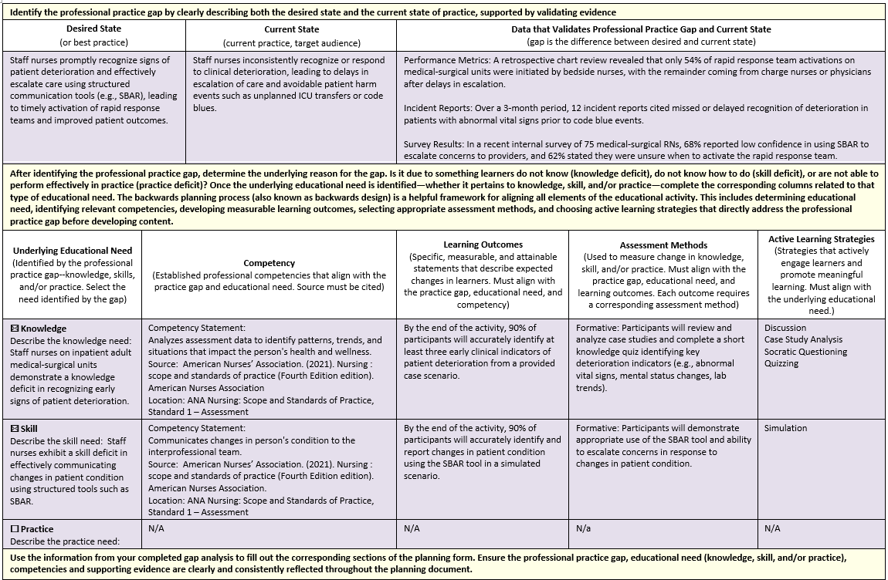

Gap Analysis
Required for ANCC Courses
Identify the professional practice gap by clearly describing both the desired state and the current state of practice, supported by validating evidence

Desired State  (or best practice) | Current State  (current practice, target audience) | Data that Validates Professional Practice Gap and Current State  (gap is the difference between desired and current state)

After identifying the professional practice gap, determine the underlying reason for the gap. Is it due to something learners do not know (knowledge deficit), do not know how to do (skill deficit), or are not able to perform effectively in practice (practice deficit)? Once the underlying educational need is identified—whether it pertains to knowledge, skill, and/or practice—complete the corresponding columns related to that type of educational need. The backwards planning process (also known as backwards design) is a helpful framework for aligning all elements of the educational activity. This includes determining educational need, identifying relevant competencies, developing measurable learning outcomes, selecting appropriate assessment methods, and choosing active learning strategies that directly address the professional practice gap before developing content.

Underlying Educational Need  (Identified by the professional practice gap--knowledge, skills, and/or practice. Select the need identified by the gap) | Competency  (Established professional competencies that align with the practice gap and educational need. Source must be cited) | Learning Outcomes  (Specific, measurable, and attainable statements that describe expected changes in learners. Must align with the practice gap, educational need, and competency) | Assessment Methods  (Used to measure change in knowledge, skill, and/or practice. Must align with the practice gap, educational need, and learning outcomes. Each outcome requires a corresponding assessment method) | Active Learning Strategies  (Strategies that actively engage learners and promote meaningful learning. Must align with the underlying educational need.)
☐ Knowledge
Describe the knowledge need:
☐ Skill
Describe the skill need:
☐ Practice
Describe the practice need:

