
Reservation Request form
Instructions
This form is required to be submitted at least three months prior to the session to initiate and guarantee a confirmation. Requests submitted less than two months prior to the session will be scheduled based on space and resource availability.
Tell us who we will be working with:
Organization*
Office of Medical Education School of Nursing Program
Hospital Department External Client
Hospital department
School of Health Program
SON MEPN GME
SON DNP SON CRNA
OME Medical Student SON Physician Assistant Other

Coordinator/Course planner*Faculty/Educator/IOR*
Please provide session details:
Title of training sessions*Course Number (e.g., ANE 440, NRS 420, etc.)Reservation Request Date – limited to 3 months*
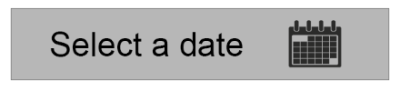
Start time (hh:mm)* End time (hh:mm)*

Alternative or additional session dates:

Learner details:
Total number of learners for Type of learners – select all
each day of training* that apply*

Session location details:
Preferred building location:
CHT Building Clinical Education Resource Center (CERC)
Education Building Betty Irene Moore Hall
External location Hospital UCDH Ambulatory
Please list your preferred room (e.g., large room, CERC, four exam rooms)

Will this session require standardized patients or models?
Yes
No
Please provide any additional details to aid in your scheduling of this course:

Attachments:
Please place any scheduling documents here.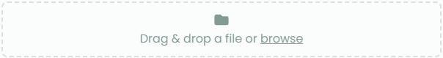
Thank you for completing Part 1 of our request process. The scheduling team will review and contact you shortly regarding space assignment for your session. We will send you Part 2 shortly to obtain additional details to support your session.
The Part 2 form is required to be submitted at least six weeks prior to the scheduled event. We appreciate the attachment of any templates with the Part 2 submission (e.g., standardized patient checklist, scripts, exam flow, scenarios, and/or equipment requirements).
Thank you, we look forward to working with you!



