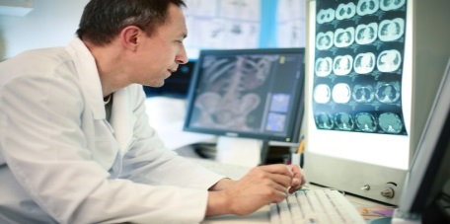
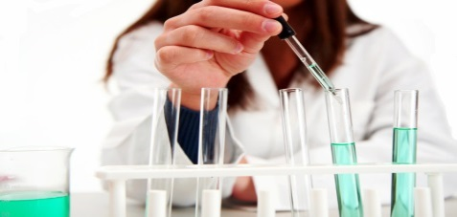

Collaborative for Diagnostic Innovation
UC Davis Department of Pathology and Laboratory Medicine
Lydia Pleotis Howell, MD, Program Director

Improving Diagnosis in Health Care

Cover Page

Project Title
Principal Investigator
Name
Title
Department
Co-PI
Name
Title
Department
12-month Budget

